Assignment 4

Dynamic Host Configuration Protocol

By Ziming Song

[zs2815@nyu.edu](mailto:zs2815@nyu.edu)

# **Part 1: Configuring DHCP**

R4:

*sudo nano /etc/dhcp/dhcpd.conf*

add below lines at the end of the file:

*subnet 10.10.11.16 netmask 255.255.255.240 {*

*range 10.10.11.17 10.10.11.30;*

*option subnet-mask 255.255.255.240;*

*option routers 10.10.11.16;*

*option broadcast-address 10.10.11.31;*

*default-lease-time 300;*

*max-lease-time 7200;*

*}*

*sudo nano /etc/network/interfaces*

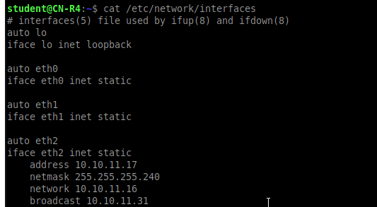

# **Part 2: Server Interface**

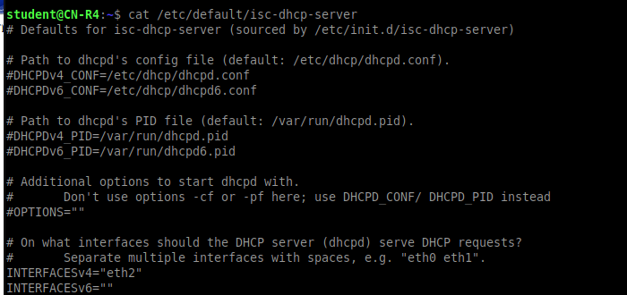

# **Part 3: Verifying DHCP and Wireshark**

*sudo systemctl status isc-dhcp-server.service*

Screenshot:

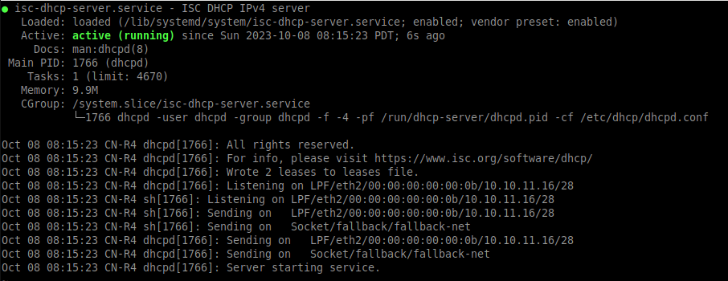

# **Submission**

## **The leases file on R4 found in /var/lib/dhcp/dhcpd.leases.**

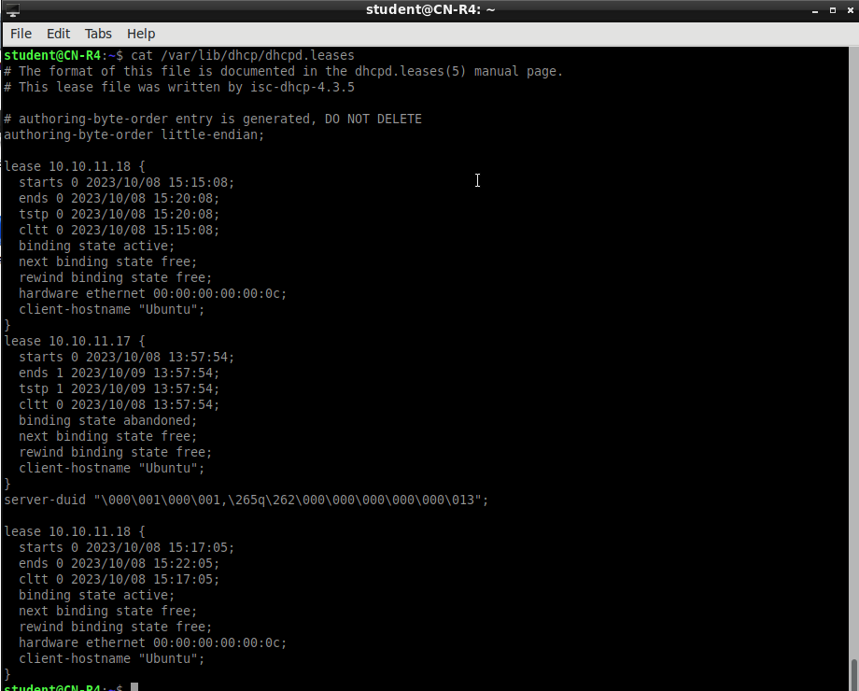

## **Your configuration for the DHCP.**

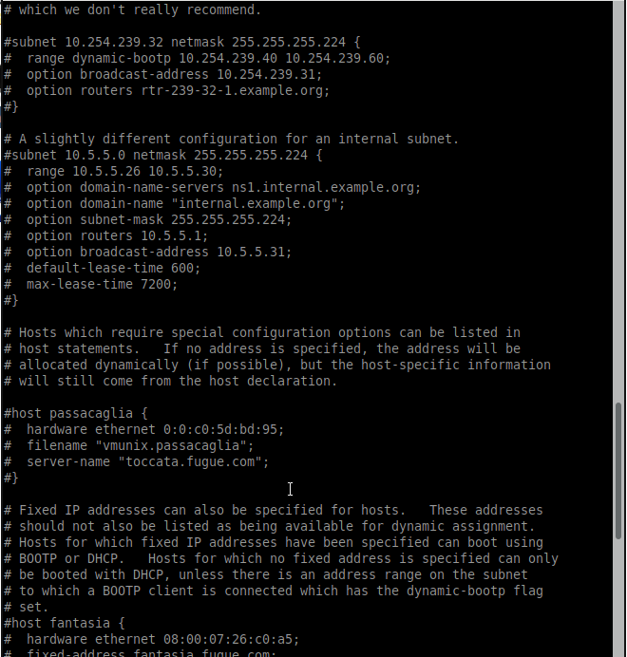

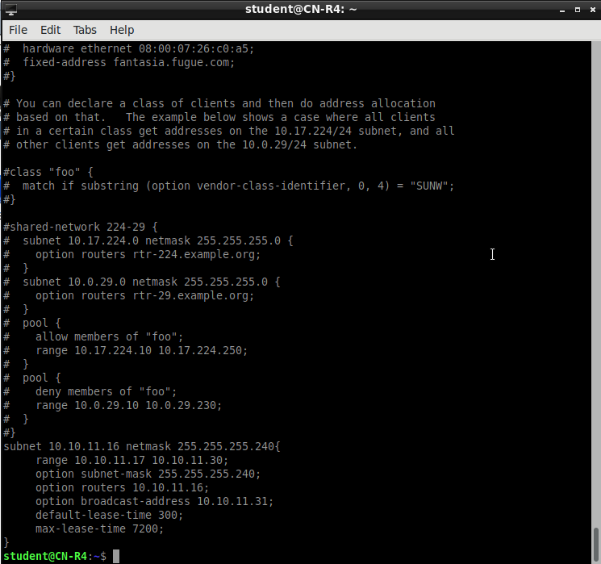

## **Screenshot of ifconfig on Ubuntu.**

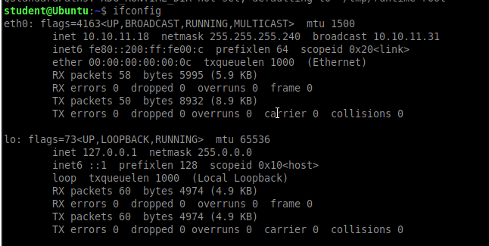

## **Screenshot showing Ubuntu pinging R4.**

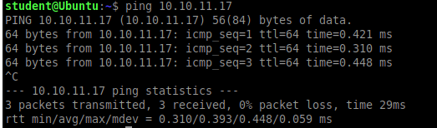

## **Screenshot showing Wireshark DHCP messages (4 Types).**

4 Types: Discover, Offer, Request, ACK

